**DAILY ONLINE ACTIVITIES SUMMARY**

|  |  |  |  |  |  |  |  |  |
| --- | --- | --- | --- | --- | --- | --- | --- | --- |
| **Date:** | **07/07/2020** | | | | | **Name:** | **RITIKA R KULKARNI** | |
| **Sem& Sec** | **4​th​ SEM. & ‘B’ SEC.** | | | | | **USN:** | **4AL19CS403** | |
| **Online Test Summary** | | | | | | | | |
| **Subject** | | **----** | | | | | | |
| **Max. Marks** | | **--** | | **Score** | | | **- -** | |
| **Certification Course Summary** | | | | | | | | |
| **Course** | **Introduction of Data Analysis** | | | | | | | |
| **Certificate Provider** | | | **Leapsapp** | | **Duration** | | | **7 Hrs.** |
| **Coding Challenges** | | | | | | | | |
| **Problem Statement: -------** | | | | | | | | |
| **Status: ----------** | | | | | | | | |
| **Uploaded the report in Github** | | | | | **---** | | | |
| **If yes Repository name** | | | | | ---- | | | |
| **Uploaded the report in slack** | | | | | **---** | | | |

**Online Test Summary:**  No internals conducted.

**Online Certification course Summary​:** I have taken new Online Certification Course in **leapsapp** . Today I went through Probability distributions.

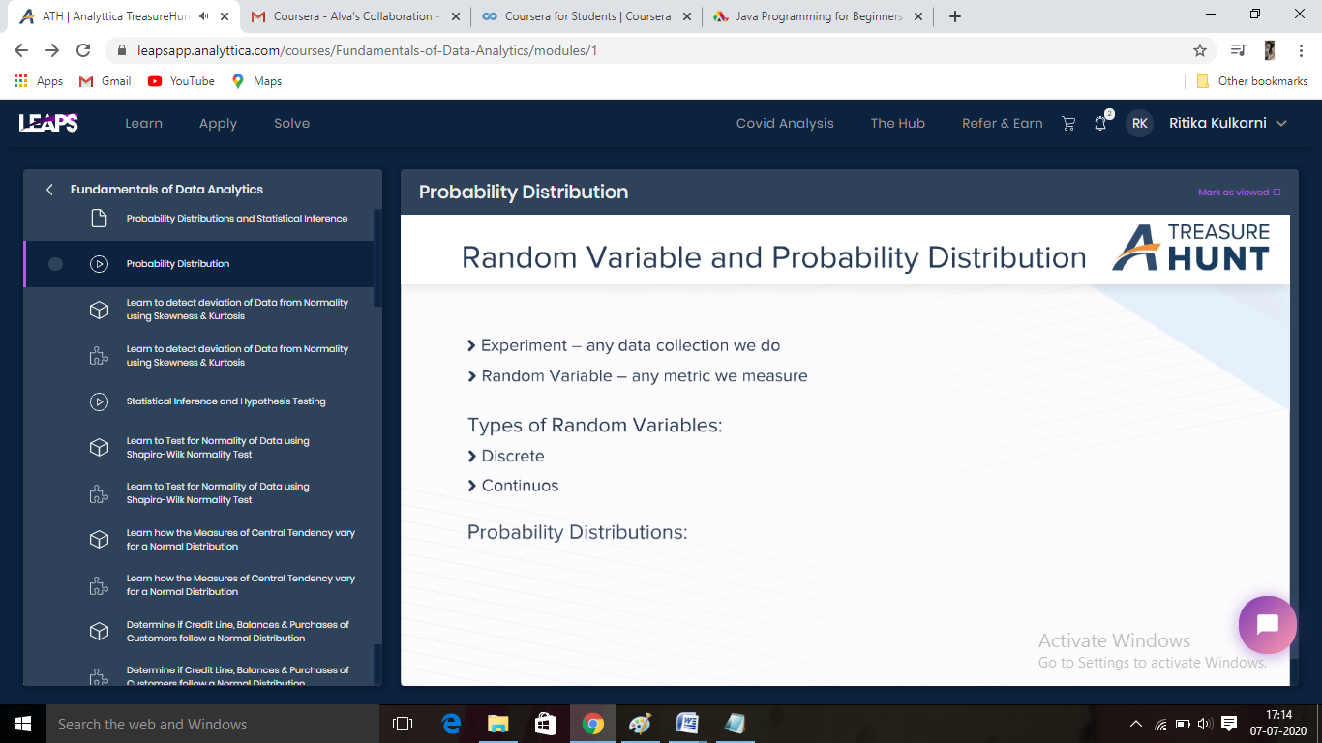

**Online Coding Summary​: No problem statements are given.**